**Multicast PROGRAM**

#include <sys/types.h>

#include <sys/socket.h>

#include <netinet/in.h>

#include <arpa/inet.h>

#include <time.h>

#include <string.h>

#include <stdio.h>

#include<stdlib.h>

#define HELLO_PORT 12345

#define HELLO_GROUP "225.0.0.37"

#define MSGBUFSIZE 50

int main(int argc, char *argv[])

{

struct sockaddr_in addr;

int fd, nbytes,addrlen;

struct ip_mreq mreq;

char msgbuf[MSGBUFSIZE];

u_int yes=1; /*** MODIFICATION TO ORIGINAL */

/* create what looks like an ordinary UDP socket */

if ((fd=socket(AF_INET,SOCK_DGRAM,0)) < 0) {

perror("socket");

exit(1);

}

/**** MODIFICATION TO ORIGINAL */

/* allow multiple sockets to use the same PORT number */

if (setsockopt(fd,SOL_SOCKET,SO_REUSEADDR,&yes,sizeof(yes)) < 0) {

perror("Reusing ADDR failed");

exit(1);

}

/*** END OF MODIFICATION TO ORIGINAL */

/* set up destination address */

memset(&addr,0,sizeof(addr));

addr.sin_family=AF_INET;

addr.sin_addr.s_addr=htonl(INADDR_ANY);

/* N.B.: differs from sender*/

addr.sin_port=htons(HELLO_PORT);

/* bind to receive address */

if (bind(fd,(struct sockaddr *) &addr,sizeof(addr)) < 0) {

perror("bind");

exit(1);

}

/* use setsockopt() to request that the kernel join a multicast group */

mreq.imr_multiaddr.s_addr=inet_addr(HELLO_GROUP);

mreq.imr_interface.s_addr=htonl(INADDR_ANY);

if (setsockopt(fd,IPPROTO_IP,IP_ADD_MEMBERSHIP,&mreq,sizeof(mreq)) <0) {

perror("setsockopt");

exit(1);

}

/* now just enter a read-print loop */

while (1) {

addrlen=sizeof(addr);

if ((nbytes=recvfrom(fd,msgbuf,MSGBUFSIZE,0,(struct sockaddr *) &addr,&addrlen)) < 0) {

perror("recvfrom");

exit(0);

}

puts(msgbuf);

}

return 0;

}

**OUTPUT**

SENDER:



LISTENER -1

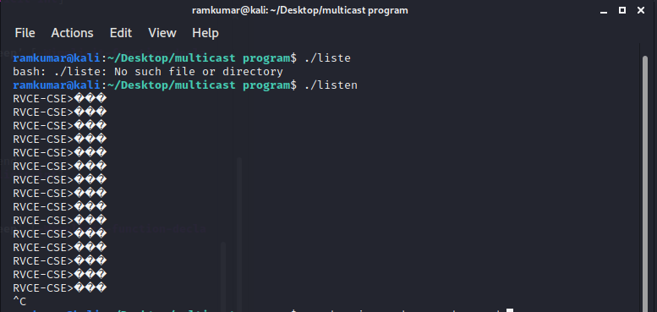

LISTENER-2

